Annealing Study of Copper Substrate for its Grain Size Optimization

**A project report submitted for the partial fulfillment of the Bachelor of Technology**

**Degree in Computer science & Engineering under Maulana Abul Kalam Azad**

**University of Technology**

BY

**Aditya Mukherjee**

(ROLL NO: 10400316225, REGISTRATION NO: 161040110362)

**&**

**Arpan Dutta**

(ROLL NO: 10400316198, REGISTRATION NO: 161040110389)

Under the Guidance of:

**Dr. G. S. Taki**

Professor

Department of Electronics & Communication Engineering, Institute of Engineering & Management

For the Academic Year 2019-2020



Institute of Engineering & Management

Y-12, Salt Lake, Sector-V, Kolkata-700091

Affiliated To:



Maulana Abul Kalam Azad University of Technology

BF-142, Salt Lake, Sector I, Kolkata-700064

**TO WHOM IT MAY CONCERN**

This is to certify that the project report entitled “**Annealing Study of Copper Substrate for its Grain Size Optimization**”, submitted by

**Aditya Mukherjee**

**(*Registration No.* 161040110362 *of 2016-2017 Roll no. 10400316225)***

&

**Arpan Dutta**

**(*Registration No.* 161040110389 *of 2016-2017 Roll no. 10400316198)***

Students of **INSTITUTE OF ENGINEERING &MANAGEMENT,** in partial fulfilment of requirements for the award of the degree of **Bachelor of Technology in** **Electronics & Communication Engineering ,** is a bona fide work carried out under the supervision and guidance of **Prof. (Dr.) G. S. Taki** during the final year of the academic session of 2016-2020.The content of this report has not been submitted to any other University or Institute for the award of any other degree.

It is further certified that work is entirely original and its performance has been found to be quite satisfactory.

_________________________________

Dr. G. S. Taki

Project Guide & Professor

Dept. of E.C.E

Institute of Engineering & Management

_________________________________

Dr. Malay Gangopadhyaya

H.O.D & Professor

Dept. of E.C.E

Institute of Engineering & Management

__________________________________________________

Prof. (Dr.) A. K. Nayak

Principal

Institute of Engineering & Management

Sector-V, Salt Lake Electronics Complex, Kolkata-700091

i

**ACKNOWLEDGEMENT**

We should like to take this opportunity to extend our gratitude to the following revered persons without whose immense support, completion of this project wouldn’t have been possible.

We are sincerely grateful to our supervisor and project guide **Prof. (Dr.) G. S. Taki** and mentors, **Mr. Samit Karmakar, SRF** and **Mr. Soumik Kumar Kundu, SRF** of the **Dept. of Electronics & Communication Engineering**, IEM Kolkata, for their constant support, significant insights and for generating in us a profound interest for this subject that kept us motivated during the entire duration of this project.

We would also like to express our sincere gratitude to **Prof. (Dr.) Satyajit Chakrabarti,** Director**,** IEM**, Prof. (Dr.) Amlan Kusum Nayak,** Principal, IEM and **Prof. (Dr.) Malay Gangopadhyaya**, H. O. D of **Dept. of Electronics & Communication Engineering** and other faculty members of Institute of Engineering & Management, for their assistance and encouragement.

Last but not the least, we would like to extend our warm regards to our families and peers who have kept supporting us and always had faith in our work.

**Aditya Mukherjee**

Reg. No: 161040110362

Dept. of Electronics & Communication Engineering

Institute of Engineering & Management, Kolkata

**Arpan Dutta**

Reg. No: 161040110389

Dept. of Electronics & Communication Engineering

Institute of Engineering & Management, Kolkata

ii

**ABSTRACT**

Annealing of 80µm Copper foils were carried out in an Electron Cyclotron Resonance Plasma Enhanced Chemical Vapor Deposition (ECR-PECVD) setup and the treated foils were characterized by XRD analysis. Here, a comparative study and analysis of such Copper foils are presented. The untreated foil on XRD characterization resulted in multiple peaks signifying multiple crystal lattice orientations, hence, a polycrystalline material. Characterizing the treated foils also resulted in multiple peaks but each of them being much sharper. Sharper peaks were a clear indication of grain sizes which were larger than that of the untreated foil. We annealed foils at several temperatures and for several holding times to determine the effects of annealing parameters on grain growth. The experiments were carried out inside an indigenously developed ECR-PECVD instrument in IEM’s Applied Materials Research Lab (AMRL). The instrument enabled us to sustain annealing environment and achieve annealing temperatures. The substrate bed was fitted with heater filaments to raise the substrate temperature, the chamber was vacuum sealed and other parameters controlled with its internal pressure being ~50 × 10-3 mbar. On analysing the characterization data by X-Ray diffraction study, suitable combination of annealing parameters was determined for optimum grain growth. Through this experiment we made significant progress towards treating cheap polycrystalline Copper foils in order to use them in suitable applications as an alternative to expensive monocrystalline Copper foils.

iii

**TABLE OF CONTENTS**

**TOPIC PAGE NUMBER**

**CHAPTER 1.****INTRODUCTION** 1

**CHAPTER 2.****LITERATURE** **REVIEW**

2.1. Annealing 4

2.2. X-Ray Diffraction 5

2.3. Crystallography 7

**CHAPTER 3.****EXPERIMENTAL SETUP AND PRACTICAL IMPLEMENTATION**

3.1. Detailed Setup 11

3.2. Brief Procedure 13

**CHAPTER 4.** **RESULTS**

4.1 XRD Peak Identification 15

4.2 Surface Enthalpy 16

4.3 Grain Size 17

**CHAPTER 5.** **CONCLUSION** 19

**REFERENCES** 21

iv

**CHAPTER 1**

INTRODUCTION

1

# 1. INTRODUCTION

The polycrystalline Copper film was annealed at two different temperatures 550°C, 650°C in a vacuum sealed chamber with a pressure of ~50 × 10-3 mbar. The experiment was carried out for various time intervals 30 min, 45 min, 60 min respectively. The experiment has been repeated for both the temperatures. These two temperatures were selected because the annealing process should be performed within 0.3 Tm to 0.7 Tm for proper recrystallization where Tm defines the melting point of the metal (here Copper). Since we were interested in grain size optimization and hence the dependence of grain size on annealing parameters, we varied the parameters to determine suitable temperature and annealing time which would result in the greater grain sizes.

Industrial synthesis of large area graphene by Electron Cyclotron Resonance Plasma Enhanced Chemical Vapor Deposition (ECR-PECVD) setup [6] requires a uniform crystalline structure of the substrate material to aid in regularity of deposition [1]. In our setup we are using Cu foil as the substrate. Since, using monocrystalline Copper foils would incur a huge cost, it is not an industrially cost-effective method. In this study we are annealing much cheaper polycrystalline Copper foils (80 um) at different temperatures for different time intervals to obtain larger monocrystalline grains. We confirm that optimizing the temperature and time intervals of annealing can lead to satisfactory grain sizes for the aforementioned graphene synthesis process. This study aims at contributing to an affordable industrial process of graphene synthesis by discounting the need for monocrystalline substrates which tend to be expensive.

Our objective is to determine the optimum physical parameters like annealing temperature and annealing time interval to obtain the best recrystallized grain size of the polycrystalline Copper substrate.

The Report has been divided into several sections. All the chapters have been continuously numbered for easy identification. Chapter 1 is introductory in nature where we establish the motivation towards this study. In Chapter 2 we are able to understand the theories behind annealing, XRD & crystallography. Chapter 3 focusses on the practical setup and discusses the procedure of the experiment. Chapter 4 contains the results of the experiment and the analysis of those results. Lastly, chapter 5 concludes the entire experiment.

2

**CHAPTER 2**

LITERATURE REVIEW

3

# 2. LITERATURE REVIEW

Recrystallisation of polycrystalline Copper to a monocrystalline one involves a great deal of accuracy and fine control of environmental parameters, especially when annealing is carried out. In this chapter we shall discuss related theories and procedures incorporated in this study, namely Annealing, crystalline surface energy along with other crystallography theories and XRD analysis, as an attempt to develop an appropriate environment for the reader.

### 2.1 Annealing

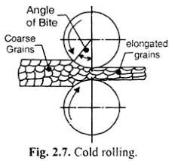After cold working a copper foil develops metastable surface imperfections and irregularity in grain shape and size. It also develops internal strain and longitudinally elongated grains. Such a film is unsuitable for uniform layer deposition because of the irregular distribution of surface enthalpy and small grain size resulting in a non-uniform lattice orientation.

One of many desired outcomes of annealing is an improved average grain size and reduced material strain. In our application we aim towards optimizing the grain size as far as possible and as a consequence enhancing the crystallographic regularity in the crystalline substance, here Copper.

Figure : Cold rolling cross-section (Source: <https://www.q8oils.com/>)

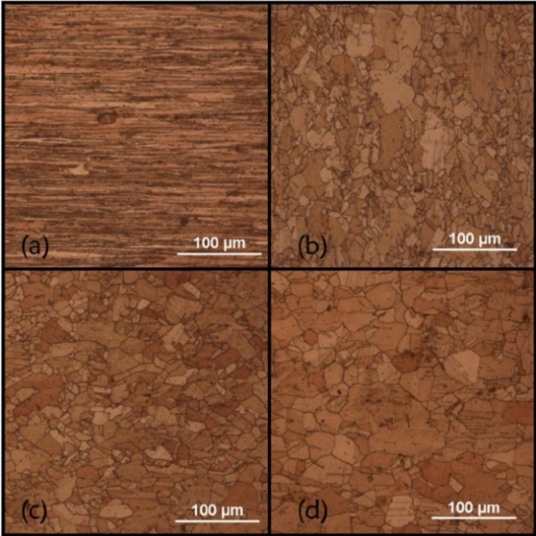The term annealing refers to a heat treatment process in which a material is exposed to an elevated temperature for an extended time period in a vacuum chamber and then slowly cooled. In this process the crystallization of a metal can be changed. Here, the physical parameters are critical and the re-crystallization process is sensitive to these parameters. If thermal energy is increased by heating a crystal to somewhere in between 0.3Tm and 0.7Tm (depends on the material), where Tm is the melting point of the material, many of the surface imperfections can be removed. Larger crystals of uniform lattice distribution grow at the expense of smaller crystals.

4

Figure : Microstructures of pure Copper. (a) As-received, (b) 450 °C annealing, (c) 600 °C annealing, (d) 750 °C annealing. [2]

Annealing process can be broken down into three stages:

* Heating up the material to a desired temperature.
* Holding that temperature for a certain amount of time.
* Cooling the material down to room temperature. Cooling rate can be varied to achieve different results. A rapid cooling rate often result in shape deformations and improper recrystallization due to undesirable grain structures.

### 2.2 X-Ray diffraction method

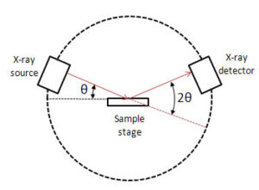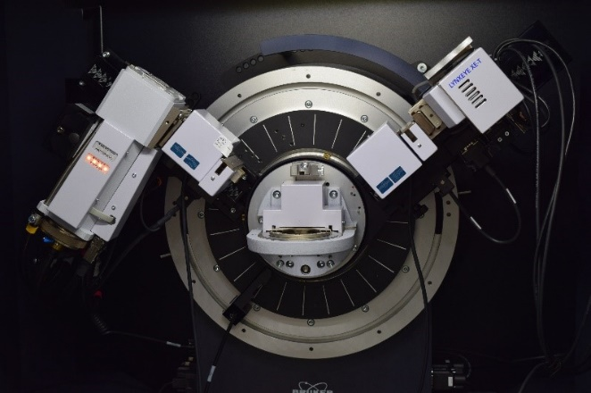Studies involving the determination of crystalline structures often turn to “X-Ray Diffraction” analysis which is based on the principles governing diffraction of electro-magnetic radiation by 3D lattice structures. Here the lattice is that of a crystalline material and the lattice points are the atoms (Figure 5). A crystalline surface diffracts X-Ray radiation and at certain incident angles (depending on the lattice orientations) results in constructive maximas which are captured on an X-Ray sensitive film or X-Ray detector (Figure 4). This phenomenon is explained by Bragg’s law.

Figure 3: Bruker D8 advance X-Ray diffractometer, grazing incidence type

The X-Ray intensity at the detector probe can be plotted on an intensity vs 2θ graph to extract information like the angles at which maximas occur, intensity of the maximas and FWHM (Full Width at Half Maxima) of the peaks (Figure 6).

Figure 4: XRD ray diagram

Bragg’s law gives us the incident angles of X-Ray at which constructive maximas can be obtained [6]. In the XRD procedure we know the frequency and wavelength (λ) of the incoming X-Ray. From XRD result (Figure 6) we also know the incident angles responsible for maximas. Therefore, we are left with only one unknown, i.e. the lattice plane separation (d). By solving the following equation (Eq. 1), we get a ‘d’ value corresponding to a unique maximum for a unique incident angle.

nλ = 2 × d × Sin(2θ) (Eq. 1)

5

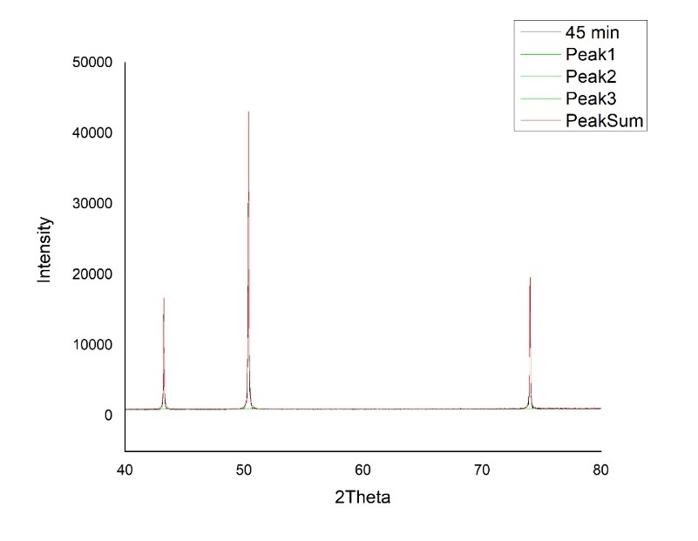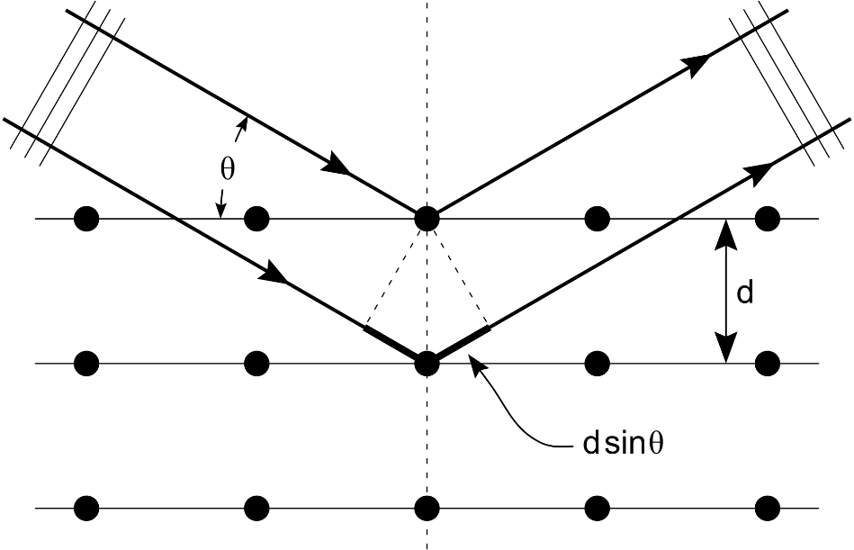

Figure 6: XRD pattern as captured on X-Ray film and plotted on a graph (After Necessary filtering)

Figure 5: XRD schematic; θ - angle of incidence, d - lattice plane separations, dSinθ - X-Ray path difference

FWHM is the width of a peak at half of its amplitude, the idea is analogous to half power bandwidth (Figure 7). FWHM has an inverse relationship with grain size of polycrystalline material. So, a material with larger grains would have sharper peaks than the ones having comparatively smaller grains (Figure 8). When dealing with sub micrometer grains one can use the Debye-Scherrer equation (Eq. 2) which relates grain size of the material to the peak width.

(Eq. 2)

Where,

* is the mean size of the crystalline domains, which may be smaller or equal to the grain size.
* K is a dimensionless shape factor, with a value close to unity. The shape factor has a typical value of about 0.9, but varies with the actual shape of the crystallite.
* is the [X-ray](https://en.wikipedia.org/wiki/X-ray) [wavelength](https://en.wikipedia.org/wiki/Wavelength).
* is the line broadening at half the maximum [intensity](https://en.wikipedia.org/wiki/Intensity_(physics)) ([FWHM](https://en.wikipedia.org/wiki/Full_width_at_half_maximum)).
* is the [Bragg](https://en.wikipedia.org/wiki/Bragg_diffraction) angle.

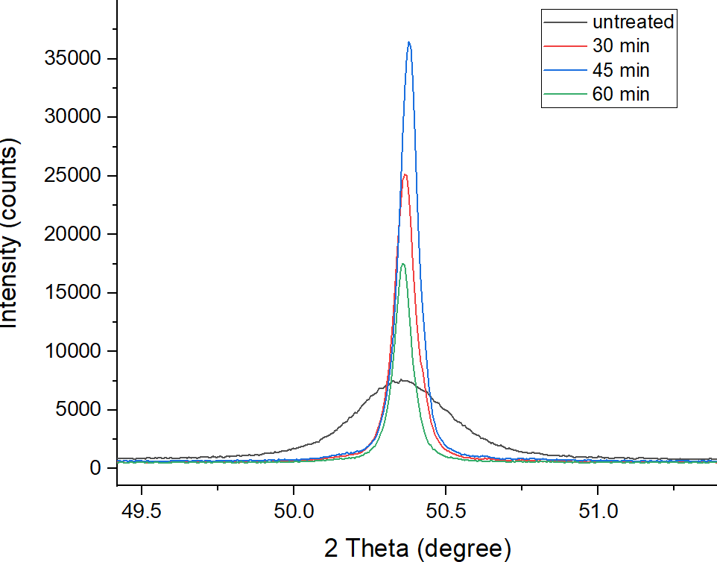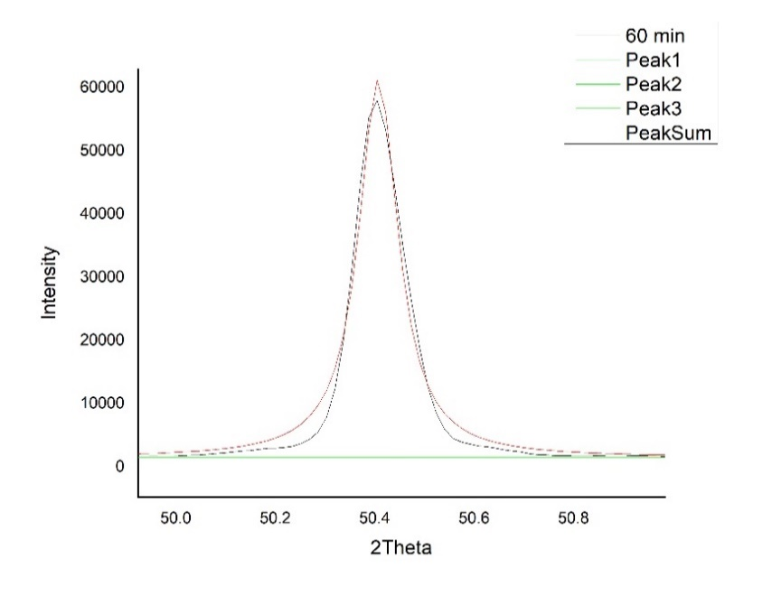

FWHM = 0.09682˚

6

Figure 8: Composite plot of untreated (black) & treated peaks

Figure 7: (approximate) FWHM of an XRD peak

For diffraction to occur the wavelength of the electromagnetic radiation should be comparable to the size of the scattering element, in the case of XRD it is the atoms in different lattice planes. The interatomic spacing of Cu crystals are acting like a slit here. The size of interatomic spacing is 2-3 Angstrom which is comparable with the X-Ray wavelength.

A beam of x-rays of wavelength lambda(λ) is directed towards the crystal at an angle theta(θ) to the atomic planes. In Bragg’s law the interaction described above between x-rays and the material is visualized as a process of reflection of x-rays by the atomic planes which are considered to be semi-transparent. That means the crystal allows a part of the x-rays to pass through and reflects the other part at the reflected angle θ which is equal to the incident angle. Theta (θ) is known as Bragg’s angle. There is a path difference between rays reflected from the first plane of the crystal and the second plane of the crystal. This two reflected will reinforce each other, when the path difference is equal to an integral multiple of the wavelength. If d is the interplanar spacing, the path difference becomes twice the distance dsinθ. Where n is an integer and lambda(λ) is the wavelength of the x-rays used.

### 2.3 crystallography

Whenever we are dealing with processes like annealing, theories and ideas of crystallography comes into the picture as these processes change the crystalline structure of the material which might change its behaviors and properties.

There are seven classifications of 3D space lattices, also called Bravais lattices. However, in this study we will only deal with a particular cubic lattice structure. There are three subdivisions within cubic lattice structure, namely, simple cubic, body centered cubic, face centered cubic. Copper lattice structure is arranged in a face centered cubic (FCC) fashion. Therefore, we shall focus our attention on FCC lattice only.

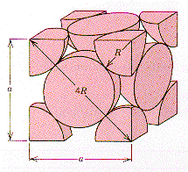FCC lattice has six lattice points at each face center which are common to two unit cells and eight lattice points at each corner which are common to eight unit cells. So, the effective number of lattice points in one unit cell can be calculated as follows –

Here, (Figure 9) ‘R’ denotes the radius of one lattice point and ‘a’ denotes the lattice point separation.

7

Figure 9: FCC unit cell

Source: www.princeton.edu

In a Copper foil this FCC lattice can be oriented in multiple planes and directions. For classification of such lattice planes we shall now look at the system of Miller indices.

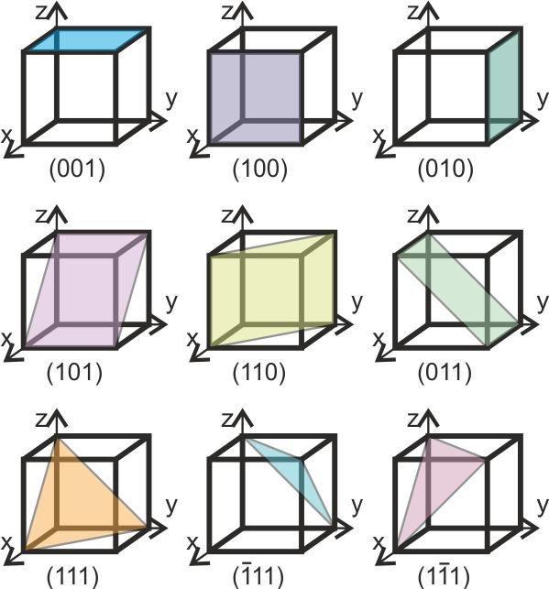

The Miller indices of a crystal plane are determined by carrying out the following steps [6]:

1. Find the x, y & z intercepts of the plane measured as multiples of the fundamental vectors.
2. Take reciprocals of the intercepts.
3. Convert them into the smallest integers in the same ratio and write them in parenthesis like (h, k, l).

Figure 10: Lattice planes & their Miller indices [3]

Lattice orientations are also determined by calculating Miller indices with the help of Eq.3.

(Eq. 3)

Where,

* d(hkl) is the interplanar separation for a particular lattice orientation and a particular set of Miller indices (Figure 11).
* ‘a’ is the length of one unit cell edge.
* h, k & l are the Miller indices for a given interplanar spacing ‘d’.

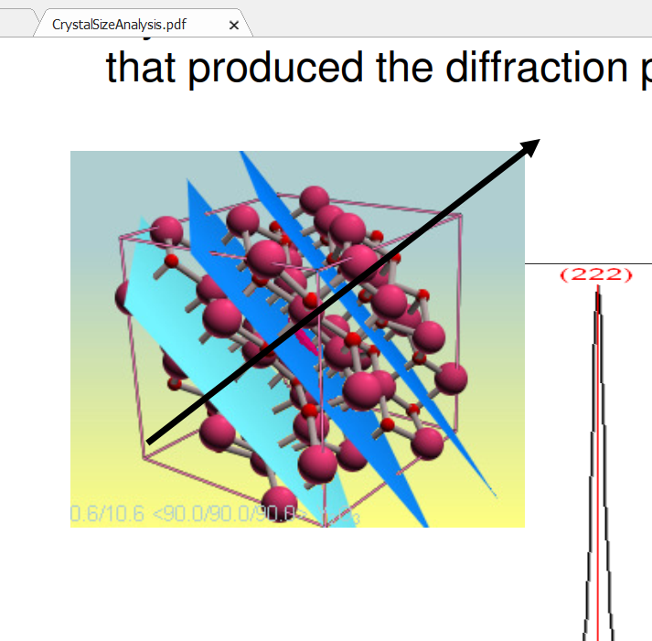

The interplanar spacing is calculated from Bragg’s equation (Eq. 1) and it is the same for all members of a family of planes, as the indices are squared and summed in the denominator. The interplanar spacing varies when the squared sum of the indices varies.

8

Figure 11: (222) lattice planes [4]

The nature of nano-material film deposition on a crystalline substrate surface is dependent on various surface properties of the crystalline material. In such surface driven processes relatively large surface area to volume ratios lead to properties which differ significantly from the bulk material. One such surface property is the surface energy or enthalpy (γ) which determines the stability of a surface. ‘γ’ is a measure of the excess energy of surface atoms compared to bulk atoms arising from various factors, such as the broken bonds yielding uncoordinated atoms. Different lattice plane orientation has different characteristic surface energies, the value depending on the number of broken bonds at the surface and the coordination number of the lattice type.

The following steps [6] would help us calculate the surface enthalpy of a particular lattice plane:

* Calculate the bond energy per atom of the material. The multiplier half is present because there are two surfaces created from one cut.

*Bond energy per atom = bond energy per bond × no. of bonds per atom × 0.5*

* Next, we need to know the ratio of the number of broken bonds to the number of total bonds. This is required to find the excess energy present in surface atoms.
* After that, the energy of broken bonds per atom can be calculated.
* Finally, multiplying the previous result with the no. of atoms on the respective plane surface per unit area, we get the surface enthalpy (γ).

S.I. unit of γ is [J/m2].

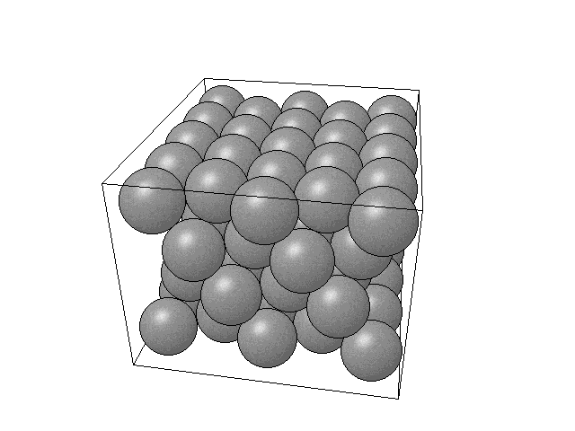

To find the number of bonds per atom in the bulk and the number of broken bonds for a surface atom we must visually inspect the lattice structure with the help of lattice simulations and illustrations (Figure 12). On critical observation we can see that any particular bulk atom is a closest neighbour to 12 atoms and any surface atom is the closest neighbour to 9 atoms. So, there are 3 broken bonds at the surface.

9

Figure 12: (111) plane of FCC lattice

**CHAPTER 3**

EXPERIMENTAL SETUP AND PRACTICAL IMPLEMENTATION

10

# 3. EXPERIMENTAL SETUP AND PRACTICAL IMPLEMENTATION

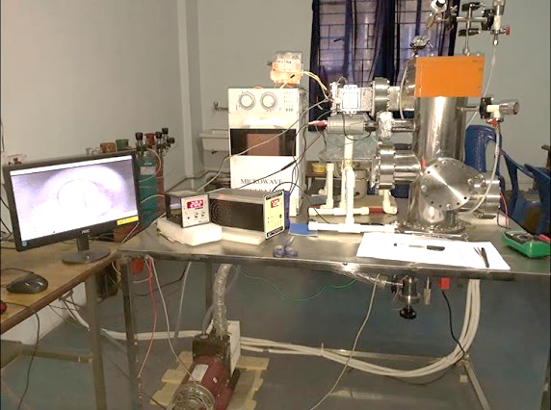Annealing of Copper foils were performed inside an Electron Cyclotron Resonance Plasma Enhanced Chemical Vapor Deposition setup (Figure 13) which is indigenously developed by Institute of Engineering & Management’s Applied Materials Research Laboratory [5].

Figure 13: ECR-PECVD setup in IEM AMRL Facility

Source: https://sites.google.com/view/iem-amrl/facilities

### 3.1 Detailed Setup

Further subsections of the experimental setup are shown in the schematic diagram (Figure 14). The substrate base was retrofitted with a filament type heating assembly (Figure 15) which was driven by a variable DC heater power supply. By varying the power supply output voltage, heater power output was varied and thus the substrate temperature could be controlled while heating up (Figure 16). The double stage rotary vane pump, the angle valve and the Pirani gauge controller generated a vacuum environment inside the chamber (~ 50 × 10-3 mbar) [1].

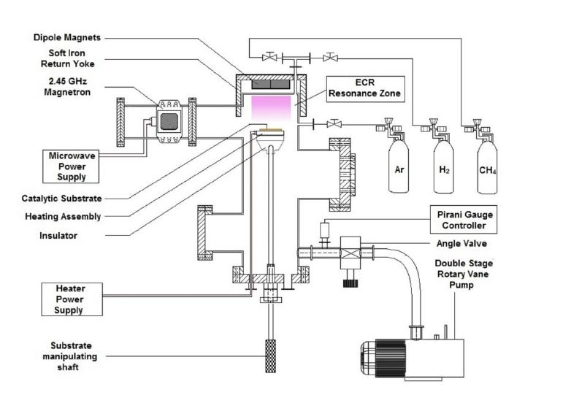

Figure 14: Schematic of 2.45GHz ECR-PECVD system where annealing of Cu foil has been carried out (reused with permission of authors [1])

11

Having both, nano-film deposition and annealing setup packaged in one combined system enabled the entire two part process of substrate preparation and then layer deposition over that substrate to be carried out as a continuous and coherent procedure. This greatly reduced the time required for the experiment and the risk of impurities being introduced in the prepared substrate.

Already in the previous chapter we discussed the disadvantages of rapid cooling when it comes to recrystallization. Therefore, it is advisable to avoid rapid cooling if proper grain growth is required. Even though this setup lacked the means of controlled cooling, we could achieve a cooling rate much slower than rapid cooling. As a result, it did not manifest any of the undesirable effects of rapid cooling. After the holding time was up, we kept the substrate in the same vacuum environment undisturbed till it cooled down. Once the material is cooled down to room temperature, it is stored carefully for XRD analysis.

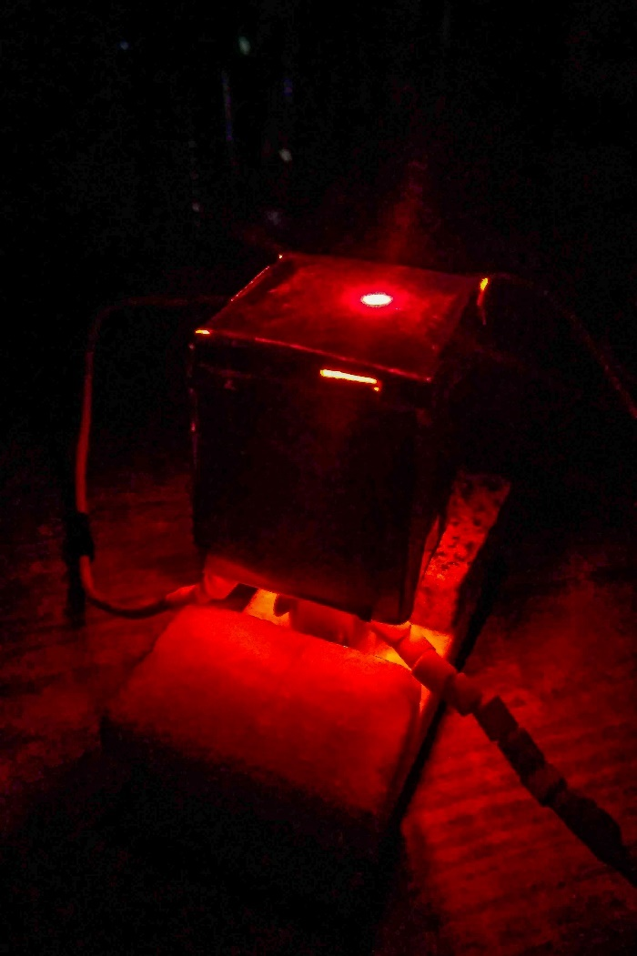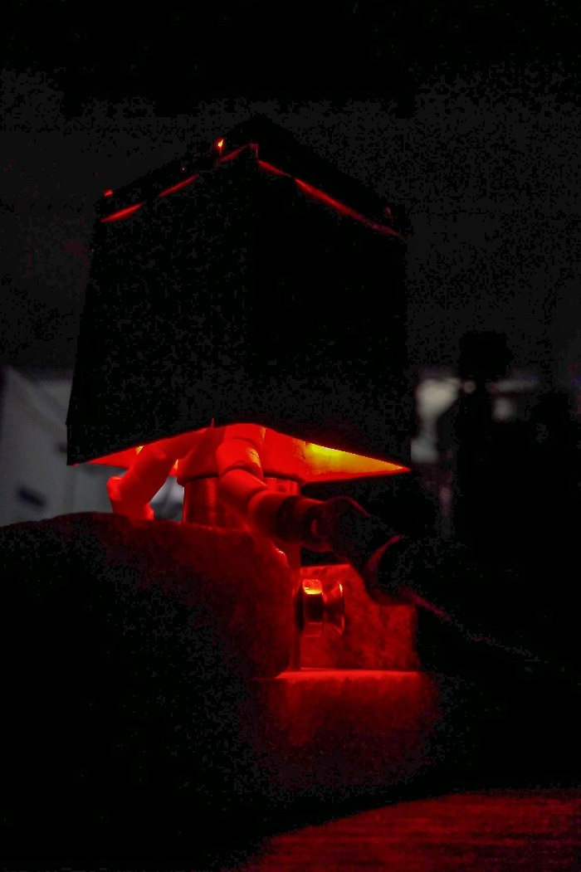

Figure 15: Glowing filament heater wrapped around a ceramic holder inside a metallic substrate bed

Figure 16: Measuring the temperature of substrate bed using LASER thermometer

12

### 3.2 brief procedure

The following flowchart summarizes the experiment and breaks it down into several steps:

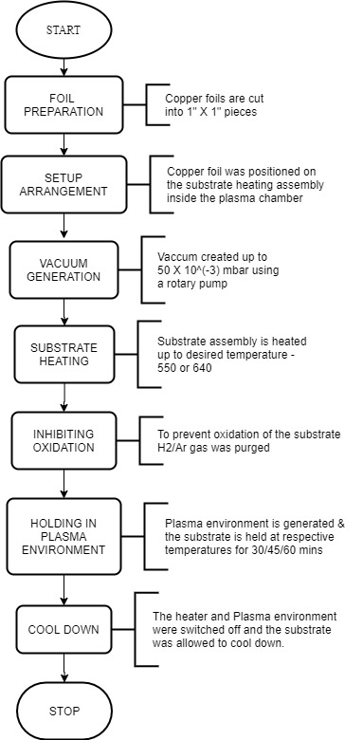

13

**CHAPTER 4**

RESULTS

14

# 4. RESULTS

For a comparative study we were required to analyze multiple samples treated at different parameters. In this chapter the analyzed information would be put forth along with the related calculations.

**4.1 XRD peak identification**

The raw data generated by X-Ray diffraction analysis had to be converted to a normalized graph which clearly shows the peaks. We took help of Origin software to accomplish that task.

Once we had a clean graph depicting the peaks, we could move on to the analysis of the peaks and determination of their lattice plane orientations using Bragg’s law (Eq. 1).

Using origin’s multiple peak fit algorithms, we determined the 2θ values for each peak (Figure 17).

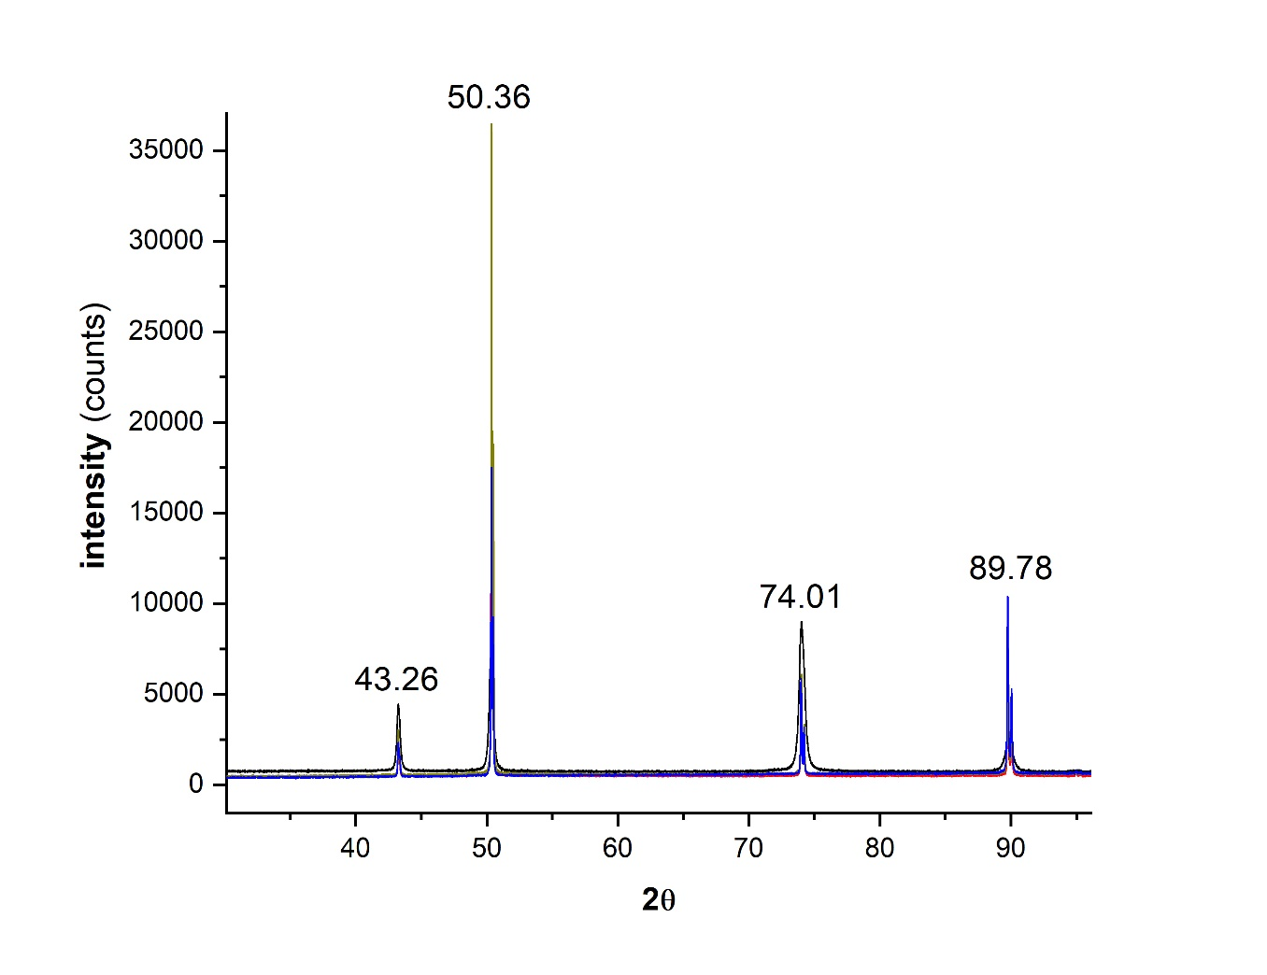

Figure 17: Composite graph of XRD peaks of untreated and treated Cu foil at 650C

Next, we applied Bragg’s law to calculate the lattice plane separation ‘d’ for each peak.

(Given, X-Ray wavelength (λ) = 1.54 [Å](https://en.wikipedia.org/wiki/%C3%85) = 0.154 nm)

|  |  |  |  |  |
| --- | --- | --- | --- | --- |
| **2θ (***°***)** | 43.25 | 50.36 | 74.01 | 89.78 |
| **d (**[Å](https://en.wikipedia.org/wiki/%C3%85)**)** | 2.08 | 1.80 | 1.27 | 1.09 |

15

Once we have the lattice plane separations, we can now apply (Eq. 3) to determine the Miller indices for the corresponding lattice planes.

(Given, lattice edge length (a) = 2√2 × r = 3.62 [Å](https://en.wikipedia.org/wiki/%C3%85) ; where r (atomic radius) = 128pm for Cu)

|  |  |  |  |  |
| --- | --- | --- | --- | --- |
| **d (**[Å](https://en.wikipedia.org/wiki/%C3%85)**)** | 2.08 | 1.80 | 1.27 | 1.09 |
| **(h, k, l)** | (111) | (200) | (220) | (311) |

Similarly, we performed the above stated analysis on Copper foils treated at 550°C which resulted in the same available lattice planes.

**4.2 surface enthalpy**

After we have an idea of the available lattice planes, we calculated the surface enthalpy for each. The determination of surface enthalpy would help us prioritise a single lattice plane in our comparative analysis. In chapter 2, section 2.3 we described how to calculate surface enthalpy for a lattice plane. The following table contains the surface enthalpies for the available lattice planes.

|  |  |  |  |  |
| --- | --- | --- | --- | --- |
| **(h, k, l)** | (111) | (200) | (220) | (311) |
| **(J / m2)** | 2.49 | 2.86 | 2.53 | 2.51 |

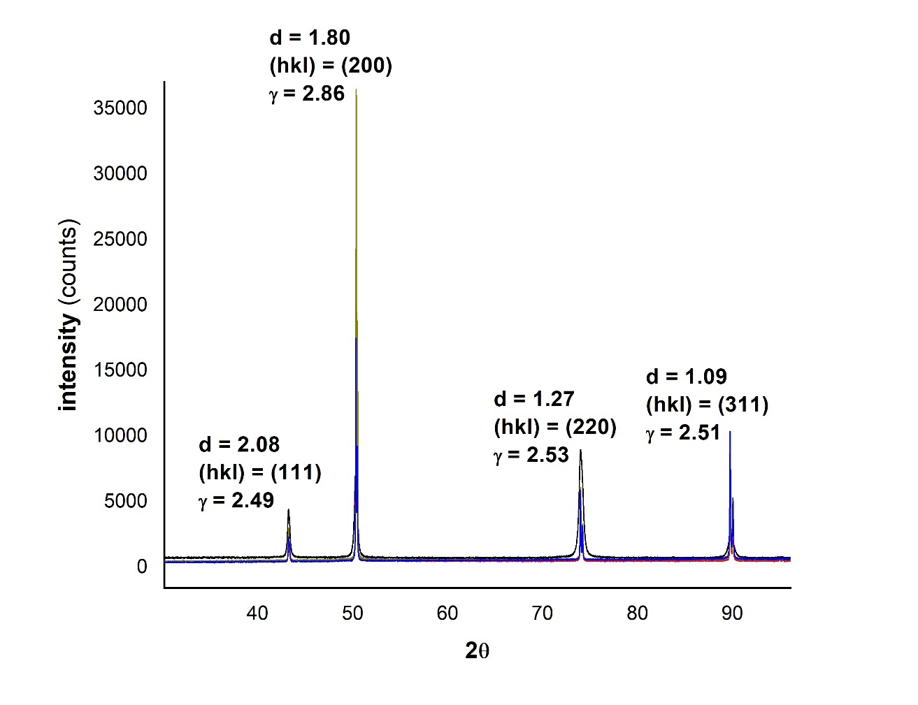

Figure 18: XRD peaks showing their Miller indices, lattice plane separation and surface enthalpies

16

Clearly (111) plane has the least surface enthalpy and hence is the most stable orientation.

In this study we would focus on maximizing the grain size of (111) plane because of its stability.

**4.3 grain size**

In order to find the grain size, it was first required to find the FWHM of the peaks. Origin peak fit algorithm also helped in an accurate approximation of the FWHM values.

From the obtained FWHM values we then calculated the mean crystalline grain sizes for each lattice plane with the help of Debye-Scherrer equation (Eq. 2).

|  |  |  |  |  |  |
| --- | --- | --- | --- | --- | --- |
| Untreated | | | | | |
| **Crystal Plane** | **Peak Position (2q)** | **FWHM** |  | **Crystallite Size D (nm)** | **D nm (Avg)** |
| 111 | 43.27229 | 0.25812 |  | 33.11032124 | 27.88017592 |
| 200 | 50.3537 | 0.31775 |  | 27.62621396 |
| 220 | 74.06109 | 0.43448 |  | 22.90399257 |

|  |  |  |  |  |  |
| --- | --- | --- | --- | --- | --- |
| 550°C 30 mins | | | | | |
| **Crystal Plane** | **Peak Position (2q)** | **FWHM** |  | **Crystallite Size D (nm)** | **D nm (Avg)** |
| 111 | 43.31683 | 0.09525 |  | 89.74020593 | 100.4244804 |
| 200 | 50.43978 | 0.08554 |  | 102.6576194 |
| 220 | 74.07625 | 0.09141 |  | 108.8756159 |
|  |  |  |  |  |  |
|  |  |  |  |  |  |
| 550°C 45 mins | | | | | |
| **Crystal Plane** | **Peak Position (2q)** | **FWHM** |  | **Crystallite Size D (nm)** | **D nm (Avg)** |
| 111 | 43.26484 | 0.07022 |  | 121.7062909 | 128.2502215 |
| 200 | 50.381 | 0.06912 |  | 127.0140756 |
| 220 | 74.02947 | 0.07314 |  | 136.030298 |
|  |  |  |  |  |  |
|  |  |  |  |  |  |
| 550°C 60 mins | | | | | |
| **Crystal Plane** | **Peak Position (2q)** | **FWHM** |  | **Crystallite Size D (nm)** | **D nm (Avg)** |
| 111 | 43.27889 | 0.09888 |  | 86.43437893 | 95.65303261 |
| 200 | 50.40711 | 0.09731 |  | 90.22869316 |
| 220 | 74.05469 | 0.09022 |  | 110.2960257 |

17

|  |  |  |  |  |  |
| --- | --- | --- | --- | --- | --- |
| 650°C 30 mins | | | | | |
| **Crystal Plane** | **Peak Position (2q)** | **FWHM** |  | **Crystallite Size D (nm)** | **D nm (Avg)** |
| 111 | 43.25311 | 0.06428 |  | 132.9475555 | 127.0132076 |
| 200 | 50.36613 | 0.07197 |  | 121.9768954 |
| 220 | 74.00974 | 0.07888 |  | 126.1151719 |
|  |  |  |  |  |  |
|  |  |  |  |  |  |
|  |  |  |  |  |  |
| 650°C 45 mins | | | | | |
| **Crystal Plane** | **Peak Position (2q)** | **FWHM** |  | **Crystallite Size D (nm)** | **D nm (Avg)** |
| 111 | 43.25647 | 0.07653 |  | 111.6682114 | 125.2790198 |
| 200 | 50.37884 | 0.06449 |  | 136.1317269 |
| 220 | 74.01768 | 0.0777 |  | 128.0371212 |
|  |  |  |  |  |  |
|  |  |  |  |  |  |
|  |  |  |  |  |  |
| 650°C 60 mins | | | | | |
| **Crystal Plane** | **Peak Position (2q)** | **FWHM** |  | **Crystallite Size D (nm)** | **D nm (Avg)** |
| 111 | 43.27535 | 0.10398 |  | 82.19394738 | 115.1649974 |
| 200 | 50.36347 | 0.06208 |  | 141.4075603 |
| 220 | 74.00611 | 0.08161 |  | 121.8934844 |

From the above results it is clearly understood that for 650°C, a holding time of 30 minutes and for 550°C a holding time of 45 minutes yield the best average grain size. Also, the optimum grain size of (111) lattice plane is obtained at these aforementioned holding time intervals for the respective temperature values, among which the (111) grain sizes of foils treated at 650°C for a holding time of 30 minutes dominate over the other. We also see that the average grain sizes of the foils treated at 650°C are larger than of those treated at 550°C.

18

**CHAPTER 5**

CONCLUSION

19

# 5. CONCLUSION

On comparing the various results, we can form an idea about a suitable set of annealing parameters for optimum recrystallisation and grain growth. From the XRD analysis it can be said that the treated foils have the peaks at the same angles as that of the untreated foil, however, the characteristics of the peaks are different signifying a change in grain parameters of the already present lattice orientations. We also determined the most stable lattice orientation available and annealing parameters for maximising the corresponding grain size.

The results also show that we have done successful work towards the use of polycrystalline Copper foil as a substrate instead of a costlier monocrystalline foil. We had promising recrystallisation results which resulted in decent grain sizes for particular annealing parameters. However, there are a lot of research yet to be done in this field to develop a process for treating polycrystalline Copper foils in order to replace the monocrystalline ones.

20

**REFERENCES**

[1] S. Karmakar, S. K. Kundu, G. S. Taki , Large area graphene synthesis on catalytic copper foil by an indigenous electron cyclotron resonance plasma enhanced chemical vapor deposition setup, arXiv preprint arXiv: 1901.06879, 2019

[2] Jilai, Wang & Fu, M & Ran, Jiaqi. (2014). Analysis of size effect on flow-induced defect in micro-scaled forming process. International Journal of Advanced Manufacturing Technology. 73. 1475-1484. 10.1007/s00170-014-5947-8

[3] Waeselmann, Naemi. (2012). Structural transformations in complex perovskite-type relaxor and relaxor-based ferroelectrics at high pressures and temperatures.

[4] Dr. Scott A Speakman, Estimating Crystallite Size Using XRD, MIT Center for Materials Science and Engineering, http://prism.mit.edu/xray.

[5] G. S. Taki, “A Permanent Magnet Electron Cyclotron Resonance Plasma Enhanced Multi-Facility Nano-Metric Film Deposition System,” Indian patent application 201731026517A (15 September 2017).

[6] V. Raghavan, Materials Science & Engineering Fifth Edition, ISBN-978-81-203-2455-8

21